Creation of IAM Roles

1.First open the Amazon web service with our amazon account .Than we have to select Identity&Access Management service (IAM).

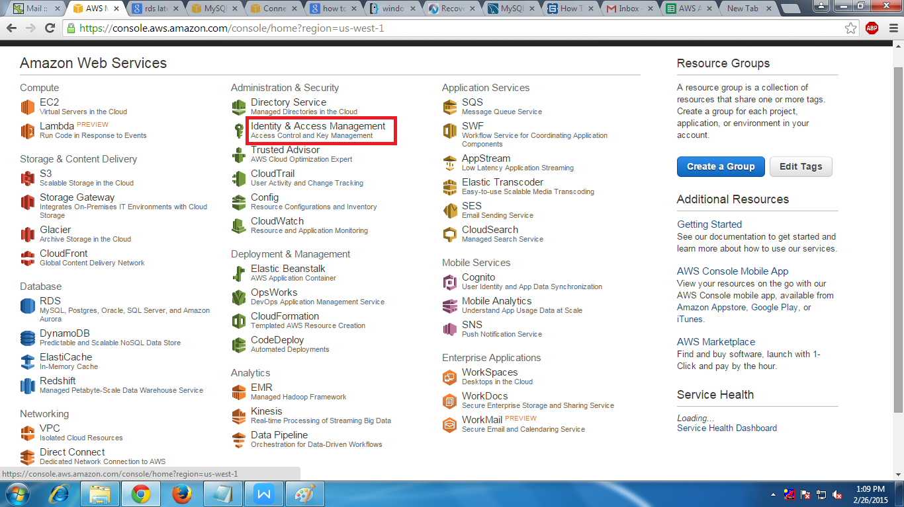

2.After selecting that option than we will find a Dashboard where we have to select Roles.

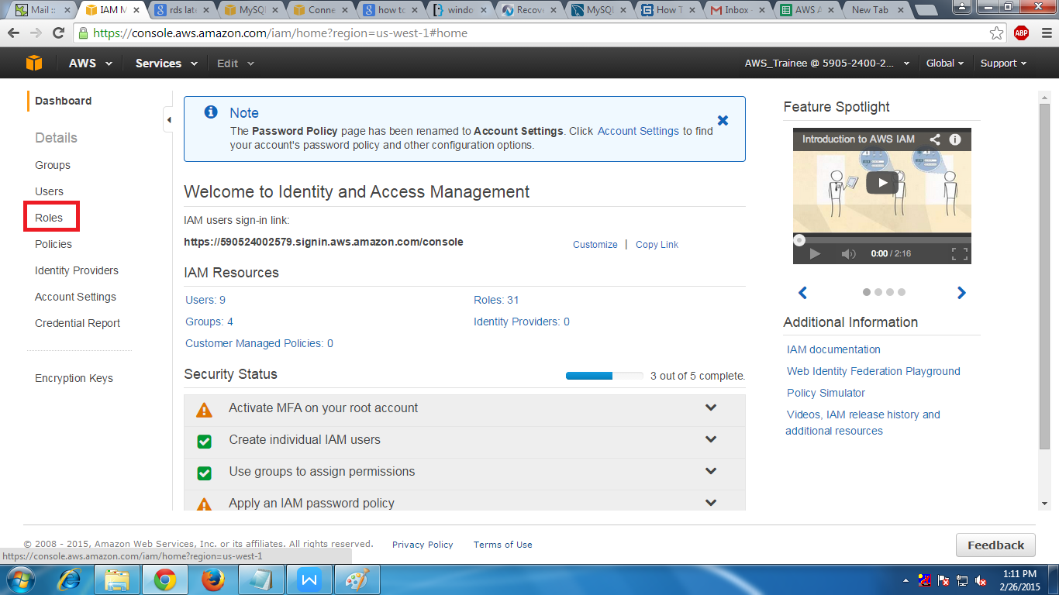

3.After that we have to click on Create New Role in that page

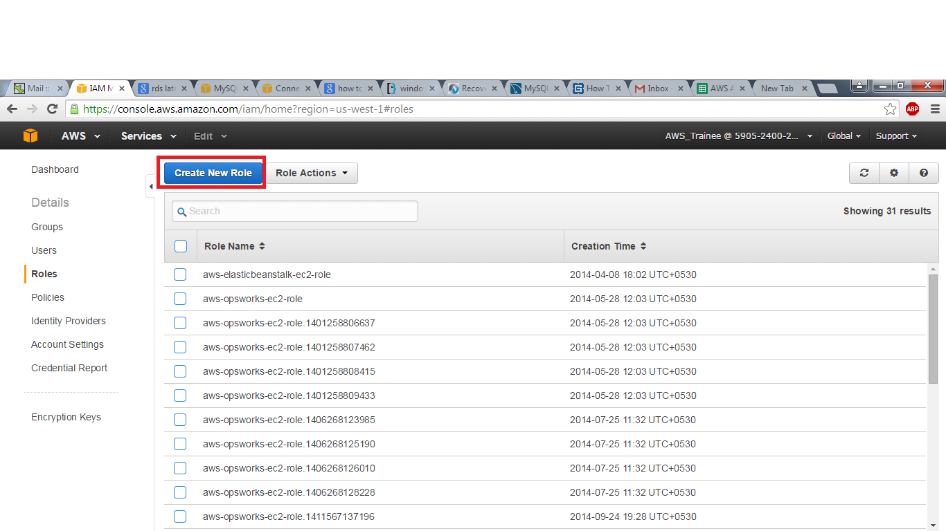

4. After that we have to set the role name.

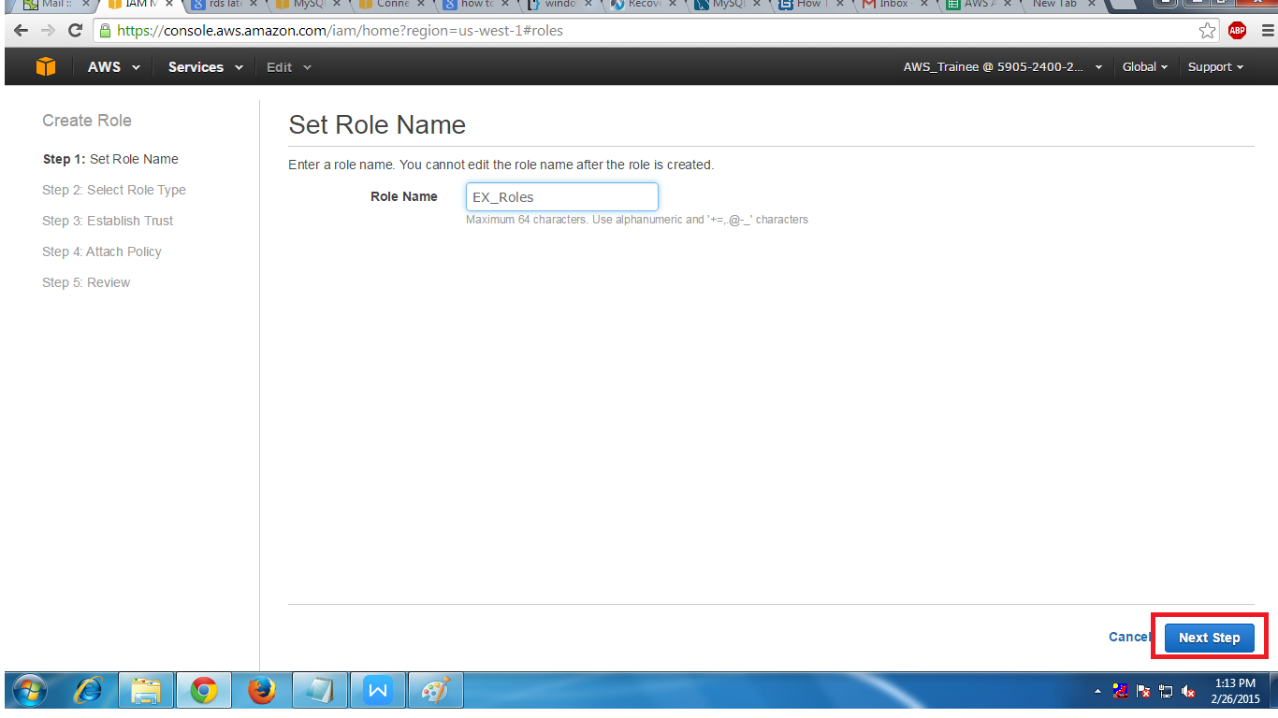

5. Than we have to select the role type for example AmazonEC2.

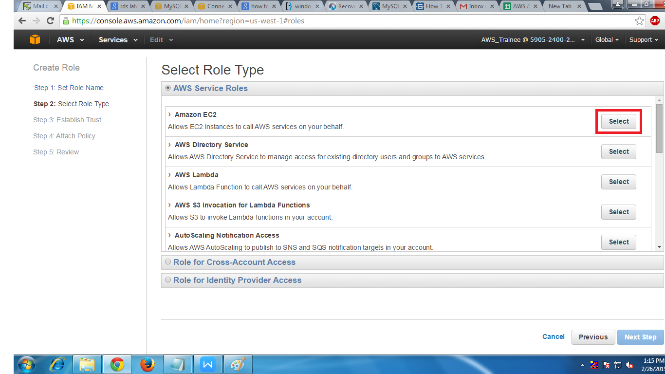

6.After that we have to check the optin as Administrator Access.

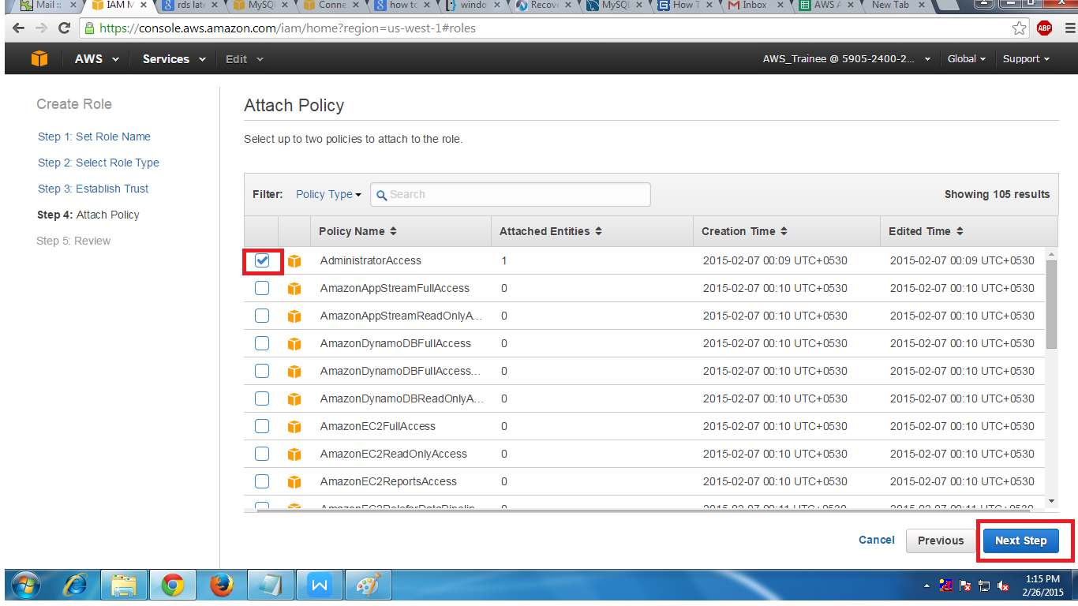

7. At last we will find the review of the option which we had selected

